**Worksheet – 3.2**

**Student Name:** Vivek Kumar  **UID:** 21BCS8129

**Branch:** BE-CSE (LEET) **Section/Group:** 809/A

**Semester:** 4th **Date of Performance:** 05/05/2022

**Subject Name:** Computer Network Lab **Subject Code:** 20CSP-257

**1. Aim/Overview of the practical:**

Create a network that implement the DHCP server.

**2. Task to be done/ Which logistics used:**

Create a network that implement the DHCP server.

**Prerequisites:**

**S/W:**

* Laptop/Desktop
* CISCO Packet Tracer program

**H/W:**

* Main Memory - 128 MB RAM
* Hard Disk – minimum 20 GB IDE Hard Disk
* 44 MB Floppy Disk Drive
* –52X IDE CD-ROM Drive
* PS/2 HCL

**3. Steps for experiment/Code with Result/Output:**

**DHCP** stands for Dynamic Host Configuration Protocol. It is a client/server protocol that automatically provides an Internet Protocol (IP) host with its IP address and other related configuration information such as the subnet mask and default gateway. RFCs 2131 and 2132 define DHCP as an Internet Engineering Task Force (IETF) standard based on Bootstrap Protocol (BOOTP), a protocol with which DHCP shares many implementation details. DHCP allows hosts to obtain required TCP/IP configuration information from a DHCP server.

Windows Server 2016 includes DHCP Server, which is an optional networking server role that you can deploy on your network to lease IP addresses and other information to DHCP clients. All Windows-based client operating systems include the DHCP client as part of TCP/IP, and DHCP client is enabled by default.

## **Benefits of DHCP**

1. **Reliable IP address configuration**. DHCP minimizes configuration errors caused by manual IP address configuration, such as typographical errors, or address conflicts caused by the assignment of an IP address to more than one computer at the same time.
2. **Reduced network administration**. DHCP includes the following features to reduce network administration:
   1. Centralized and automated TCP/IP configuration.
   2. The ability to define TCP/IP configurations from a central location.
   3. The ability to assign a full range of additional TCP/IP configuration values by means of DHCP options.
   4. The efficient handling of IP address changes for clients that must be updated frequently, such as those for portable devices that move to different locations on a wireless network.
   5. The forwarding of initial DHCP messages by using a DHCP relay agent, which eliminates the need for a DHCP server on every subnet.

**Procedure:**

Open the Cisco Packet Tracer Application in your Computer

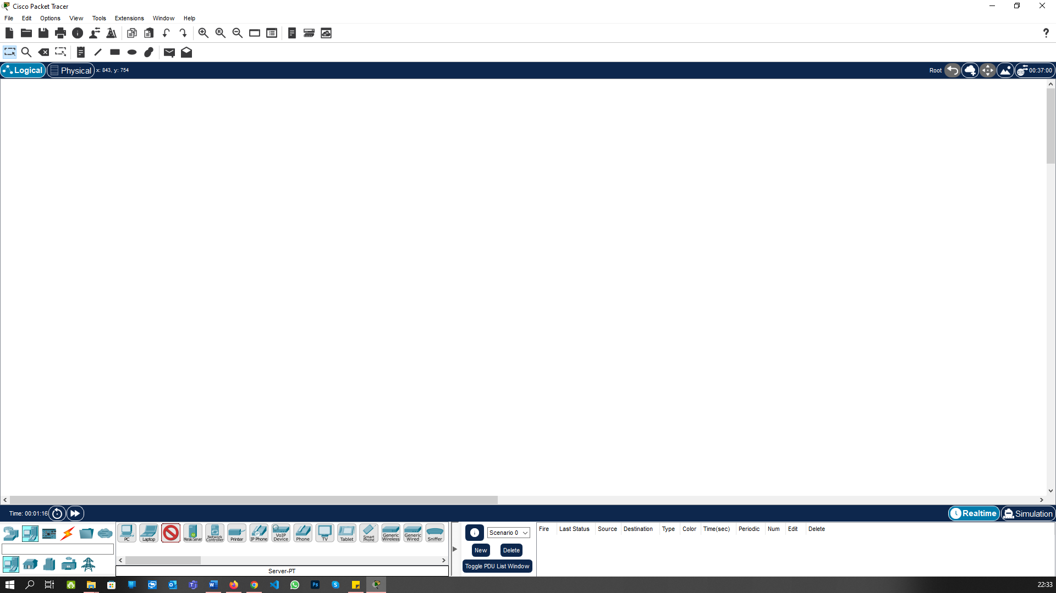

Go to the Bottom Bar “Network Devices -> Routers” and create the Router:

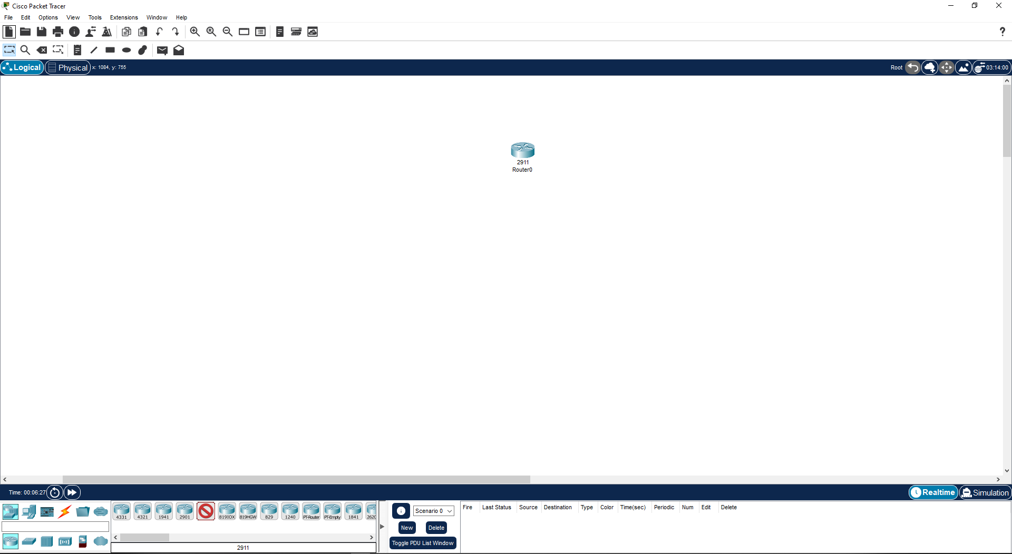

Go to the Bottom Bar “Network Devices -> Switchers” and create the two switches:

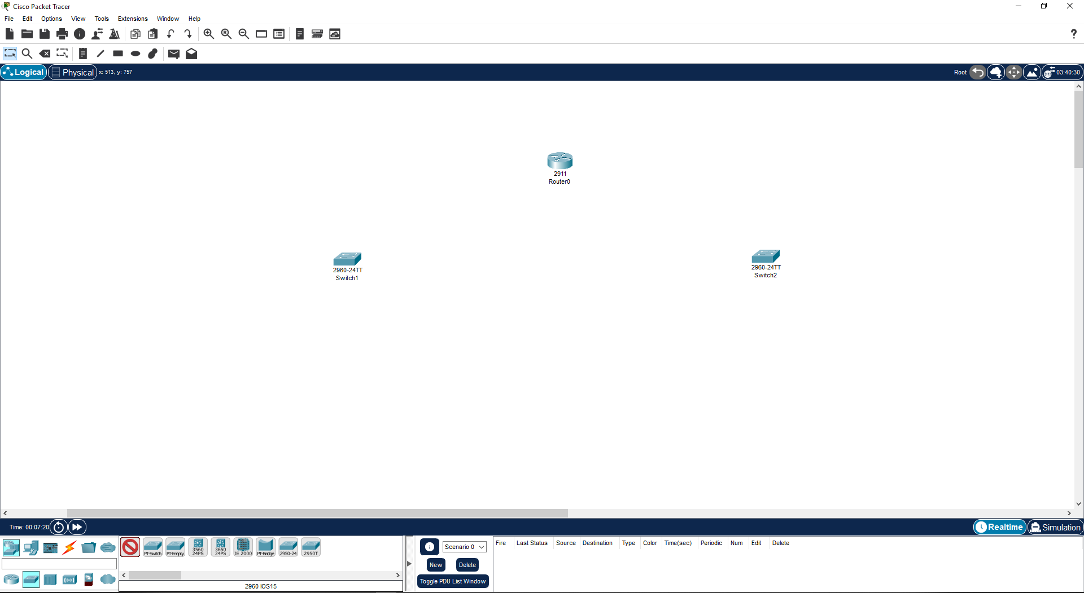

Go to the Bottom Bar “End Devices -> Servers” and create the server:

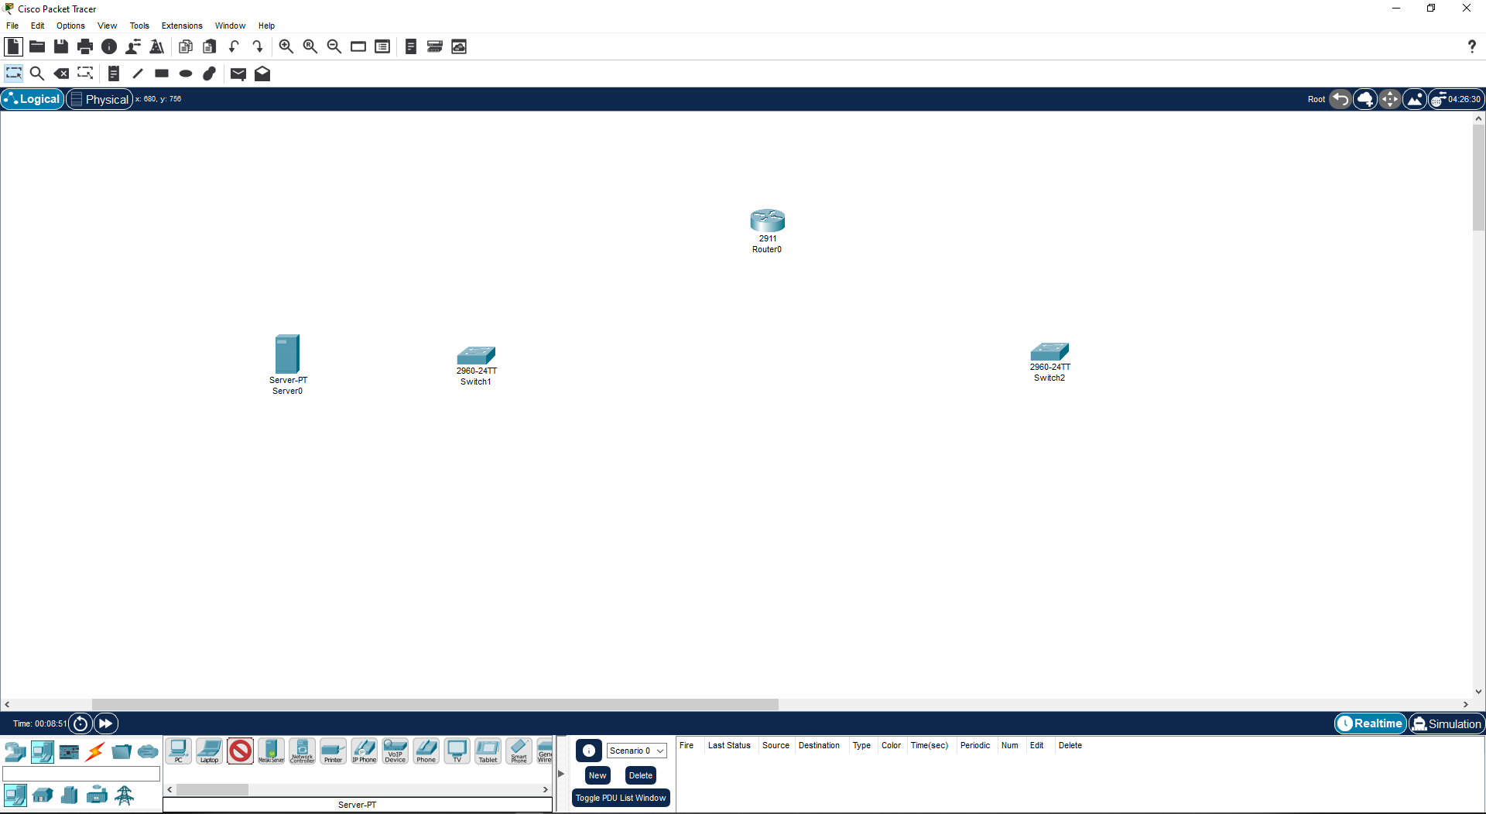

In Bottom Bar “End Devices -> PC” and create the 3-3 PCs for each Switches:

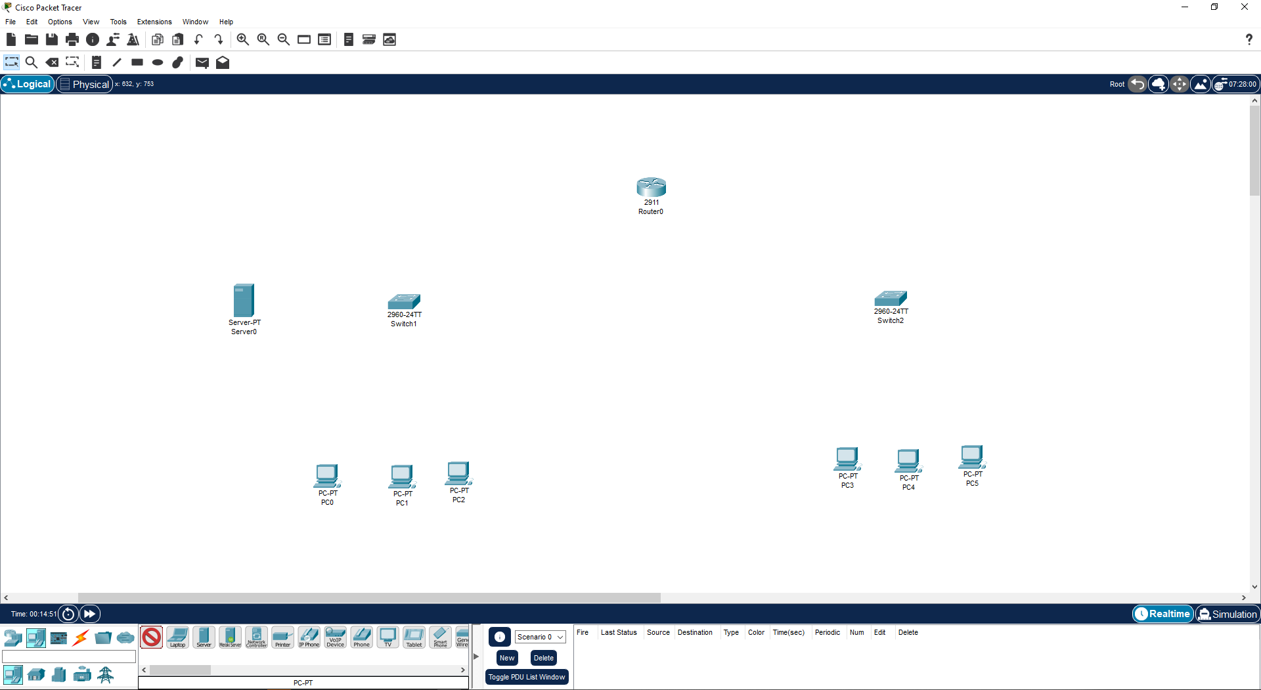

In Bottom Bar “Connections -> Copper Straight-Through” and create the connections between all the Devices:

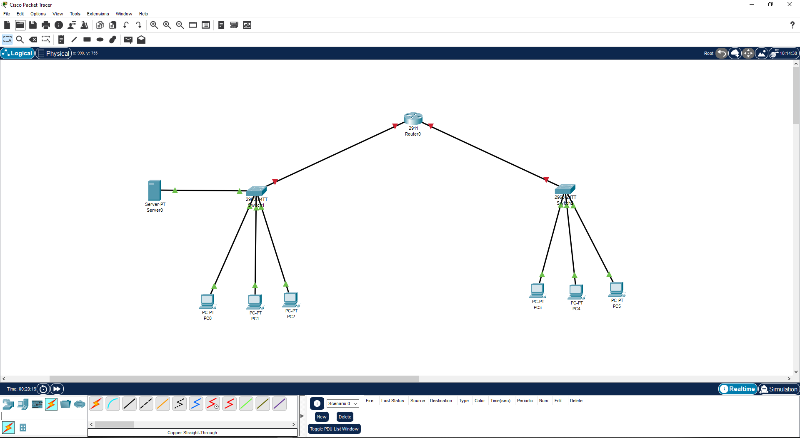

Now Open the Server configuration -> Config -> Change the Display Name to DHCP Server

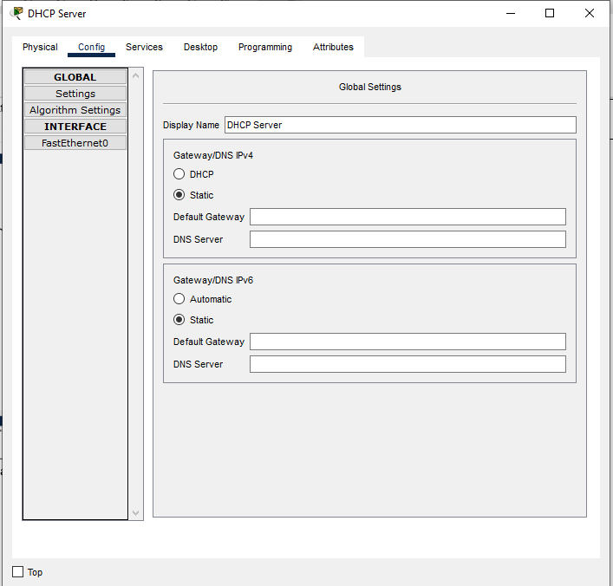

Open Fast Ethernet 0 and assign the ip-address

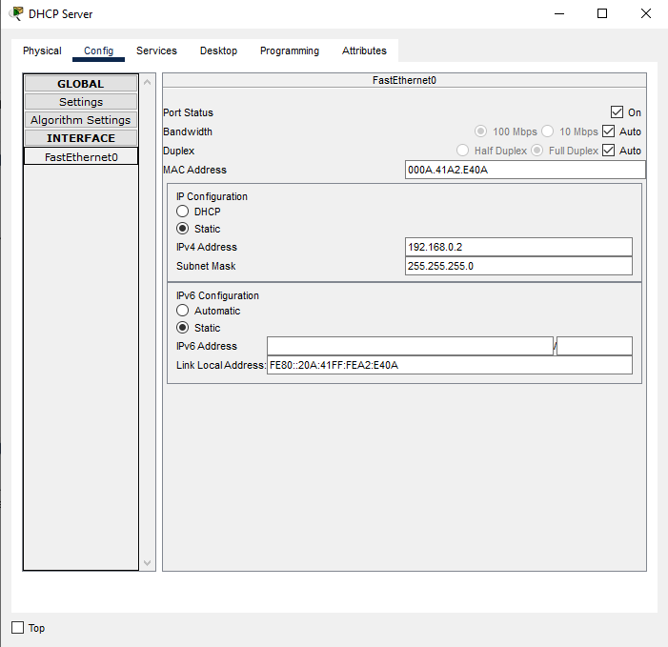

Go to services->DHCP and add the Serverpool left and right assign the Default gateway 192.168.0.1 & 172.0168.0.1 respectively.

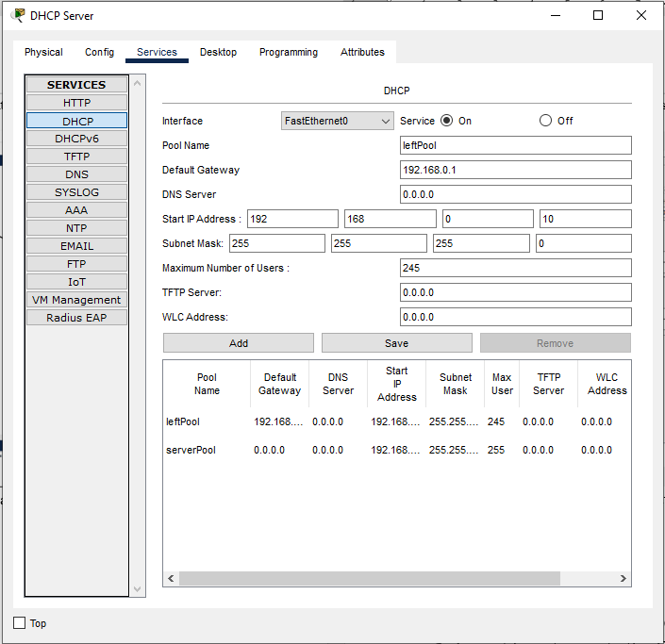 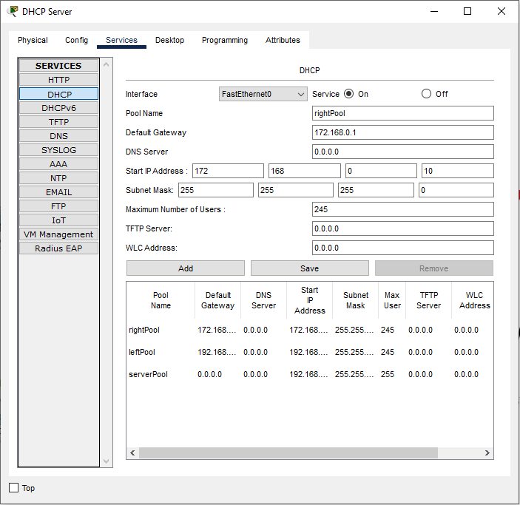

Now Remove the ServerPool content which was default added and make it 0 all.

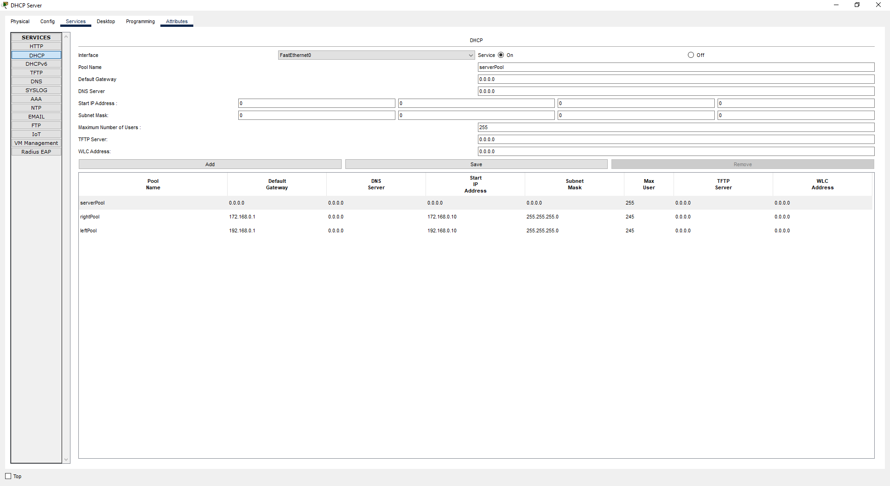

Now Go to the Server Configurtion and select GigabitEthernet0/0, Turned it onand assign the ip address for left Network.

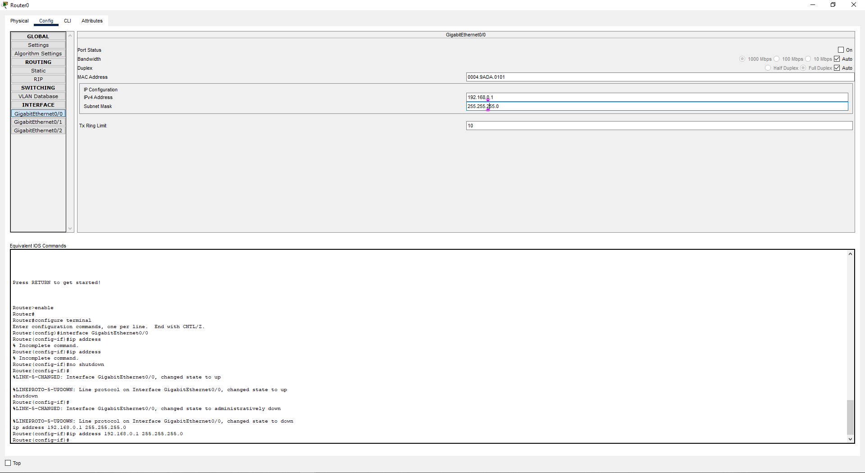

Now Select the GigabitEthernet0/0, Turned it On and assign the ip address for right Network.

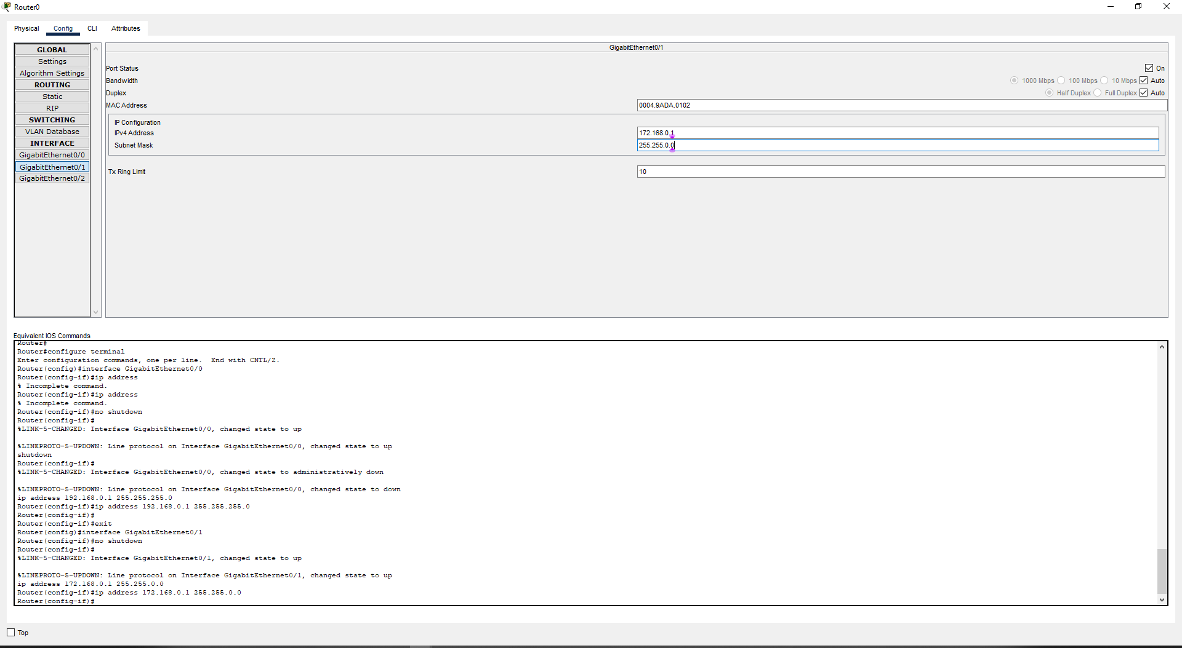

Now goto CLI section and ruh the respective commands.

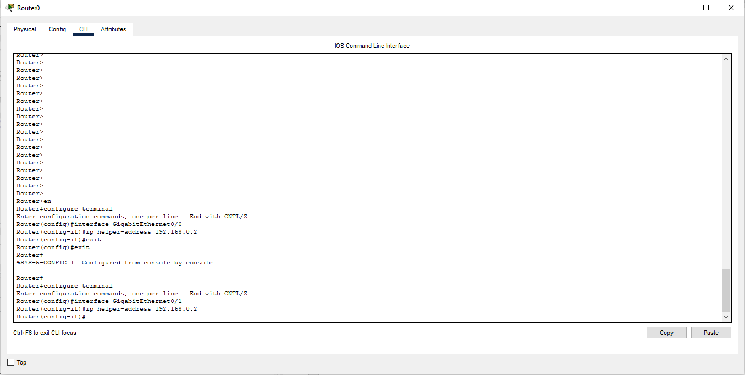

Now in LeftPool/LAN-1 goto the PC0 Desktop -> Select IP Configuration

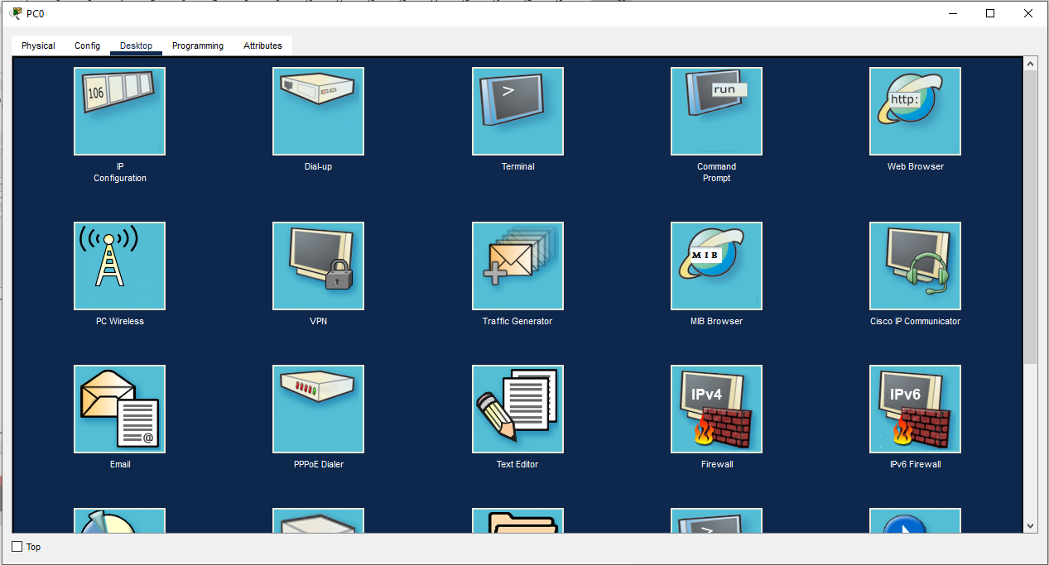

Select the DHCP mode and it will automatically request the DHCP Ip address

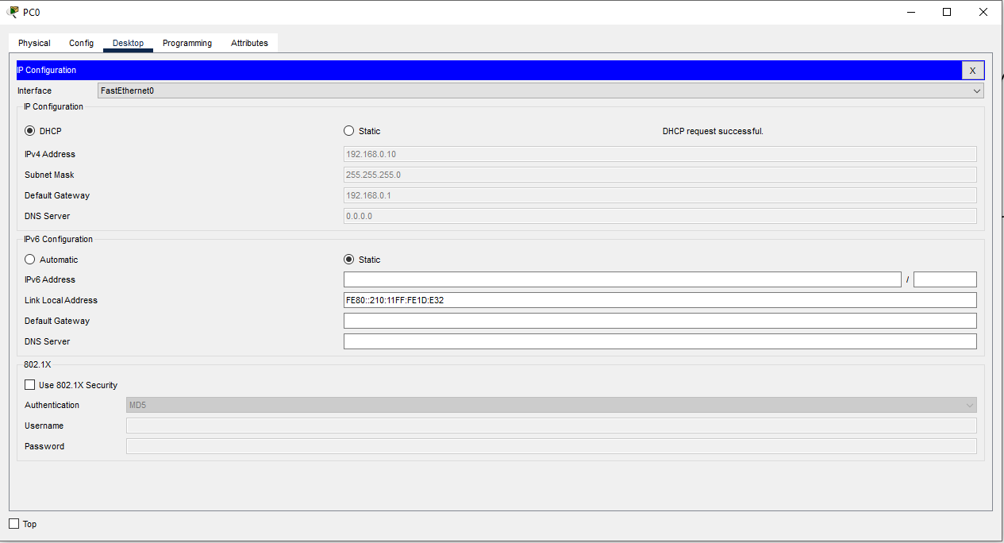

Do the Same for All PC

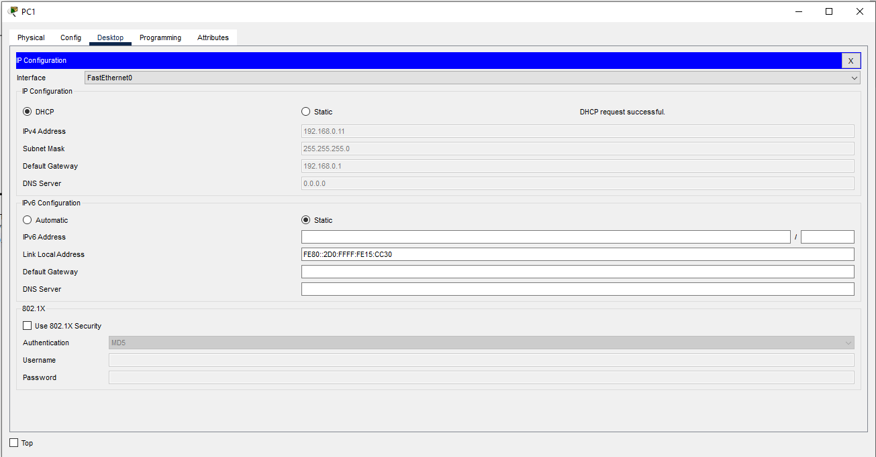

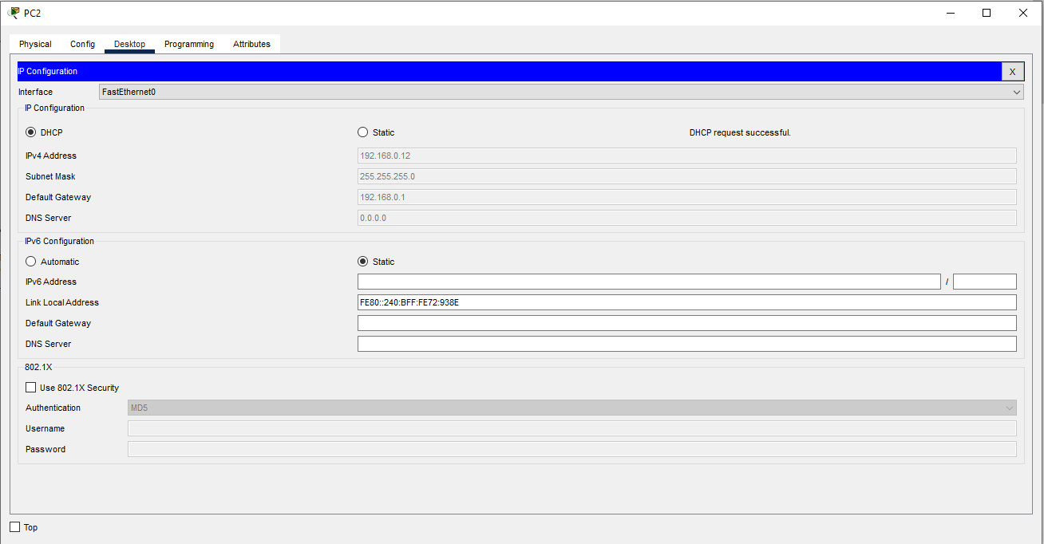

Now in RightyPool/LAN-2 goto the PC3 Desktop -> Select IP Configuration

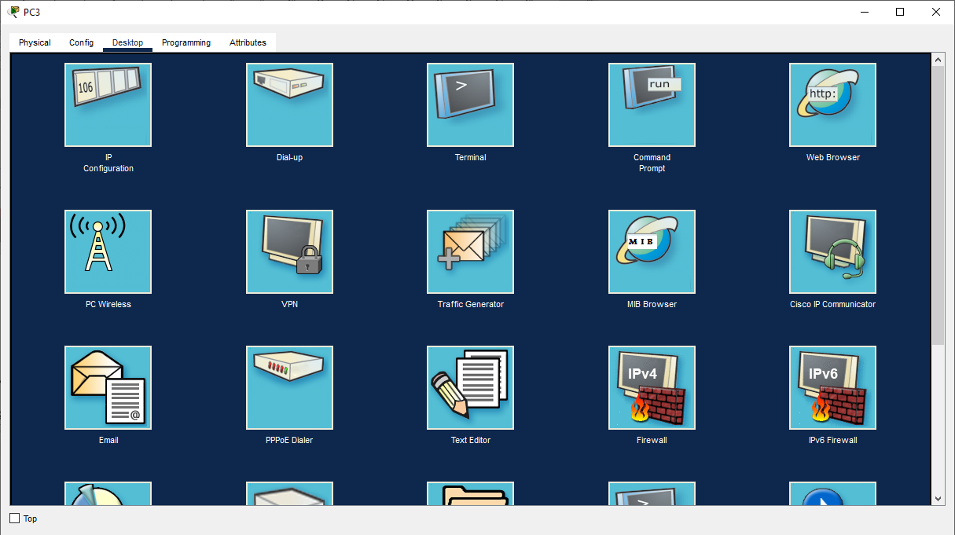

Select the DHCP mode and it will automatically request the DHCP Ip address

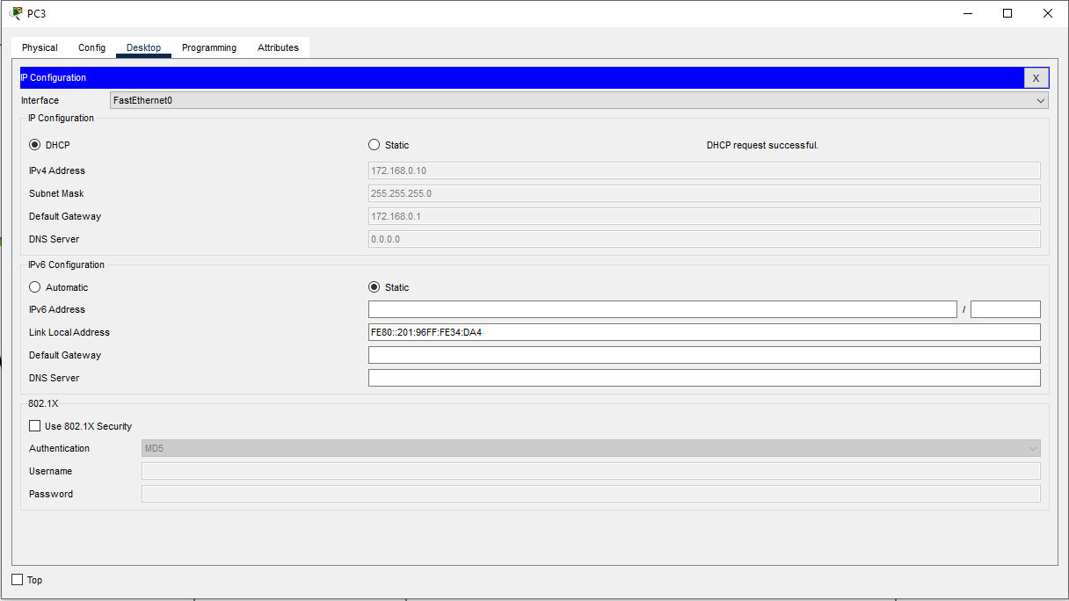

Do the Same for All PC

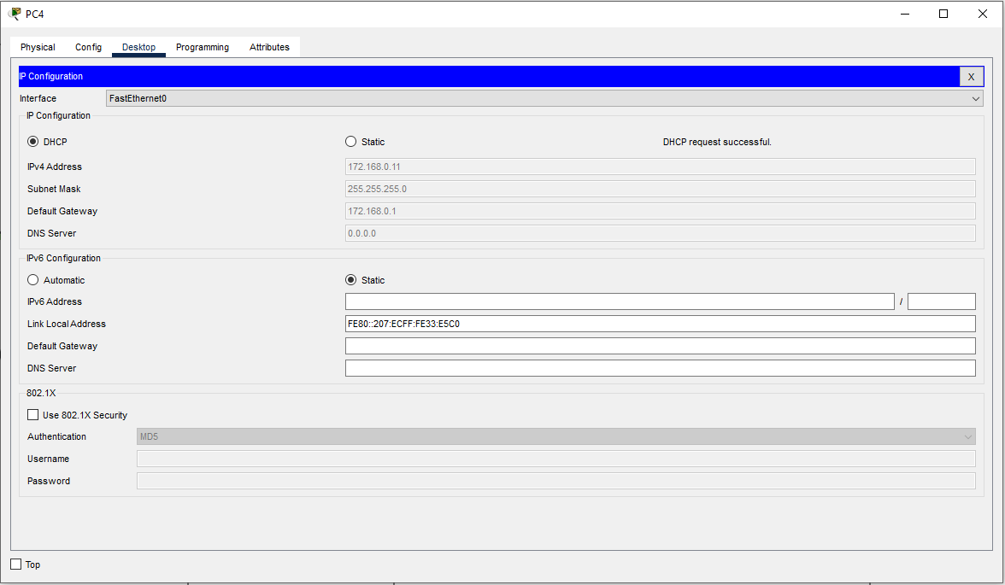

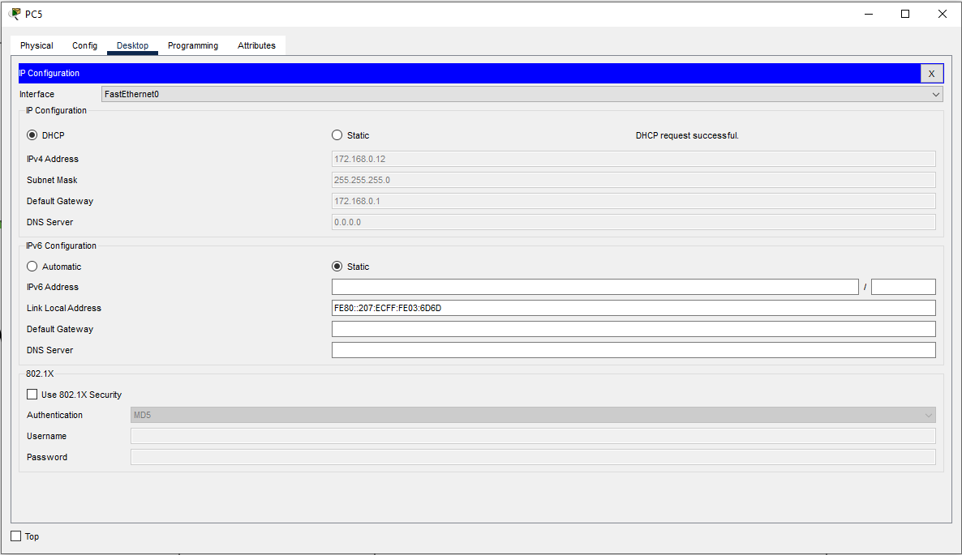

Finally I’ve completed the all connectio and IP addressing of the Network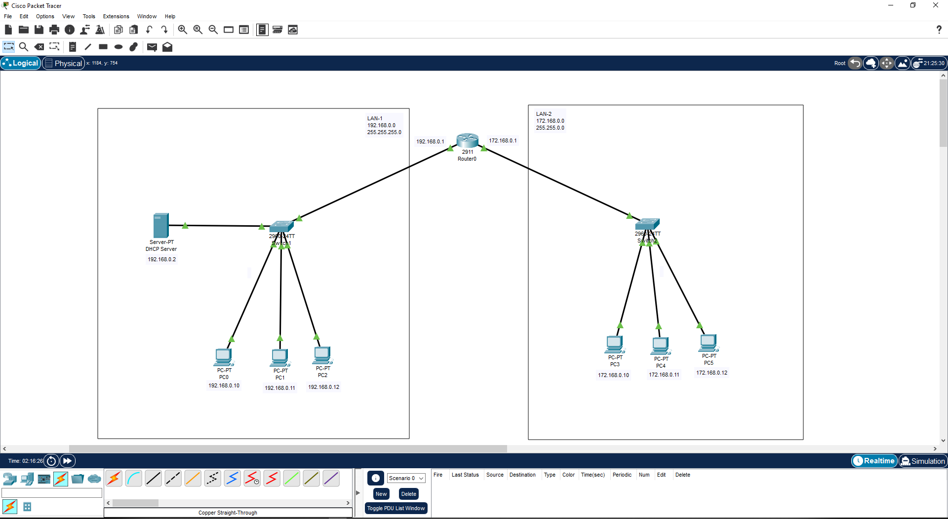

Now in Simulation mode I’ll send the message from PC0 to PC4 and record the Simulation process.

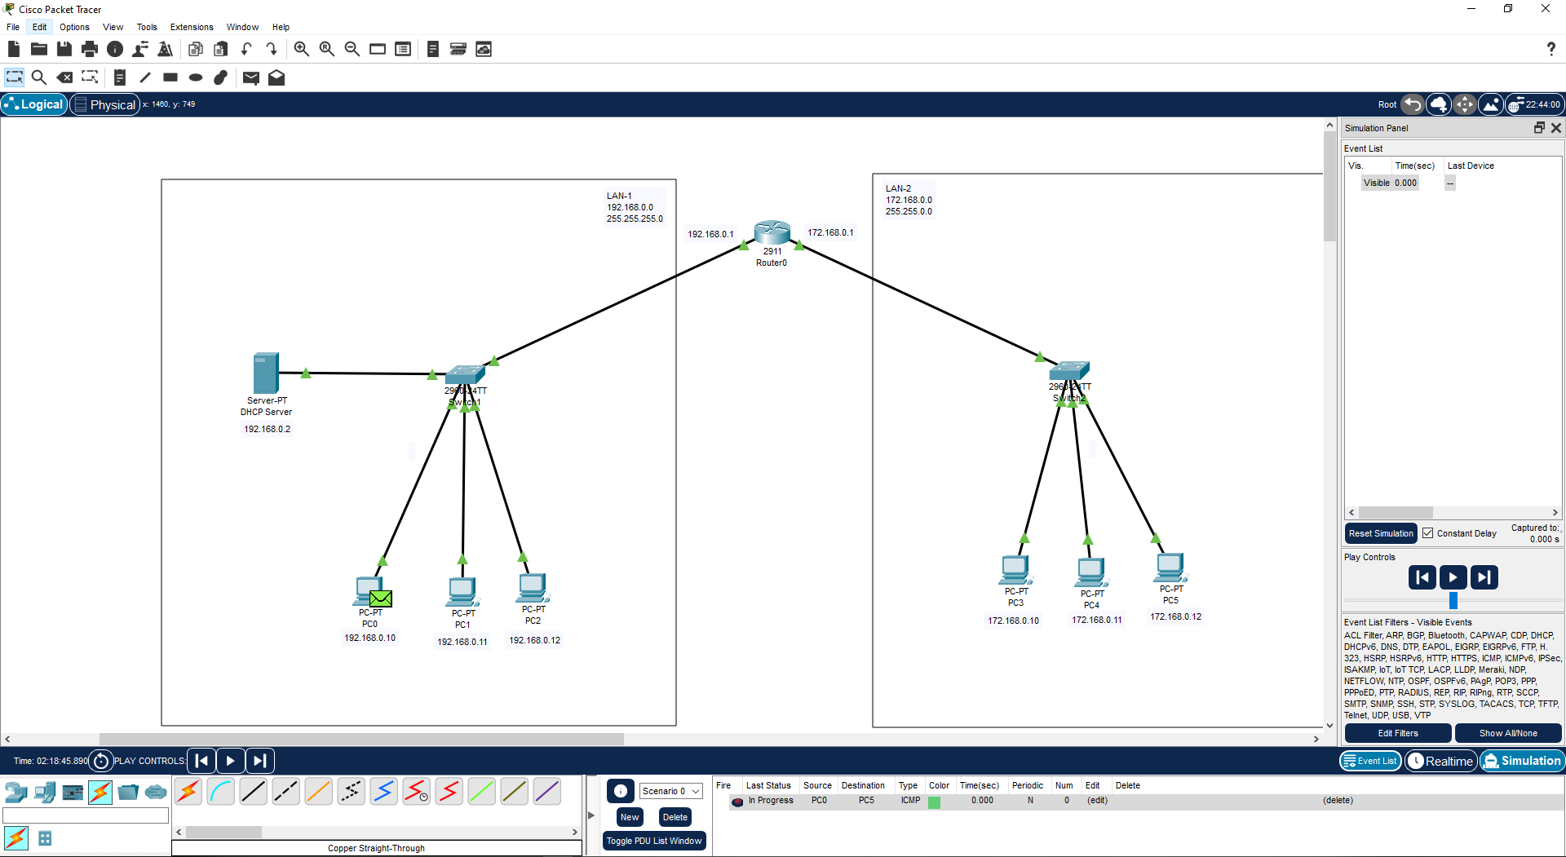

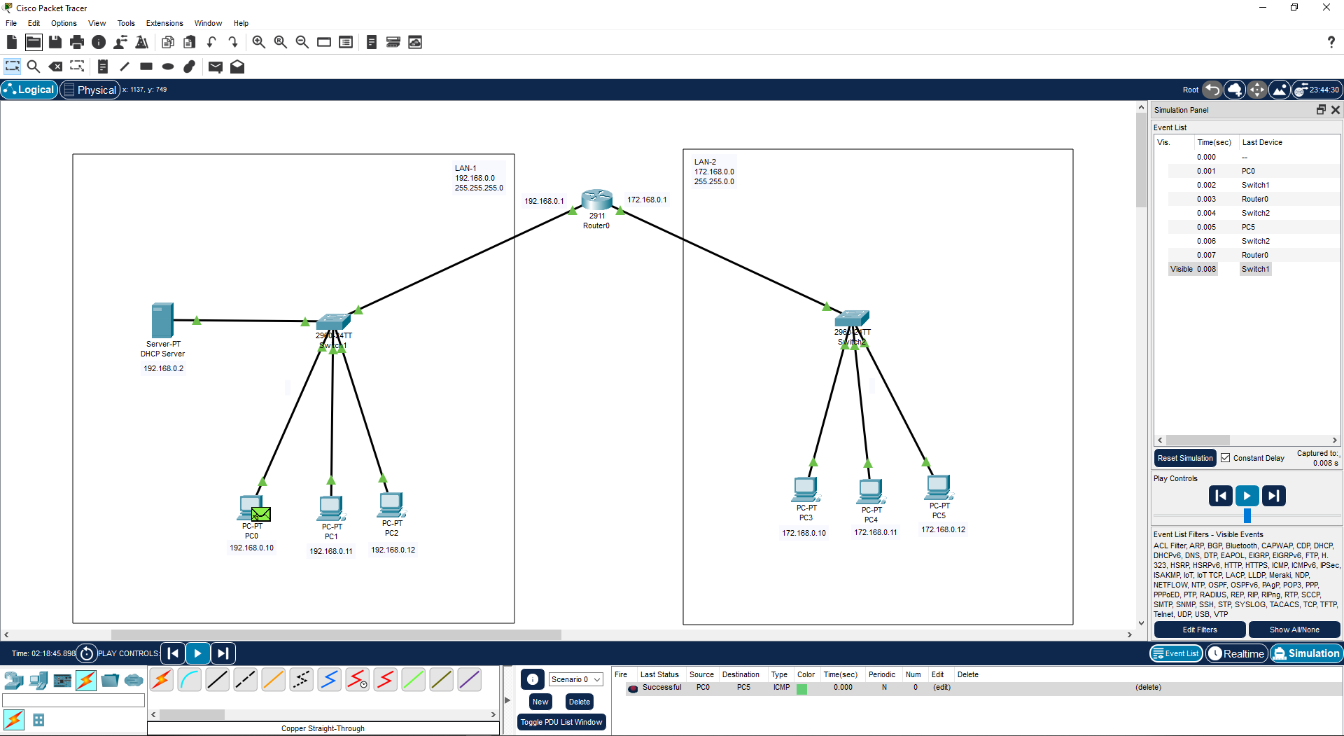

**Learning outcomes (What I have learnt):**

**1.** Learnthow to create the DHCP Server connection.

**2.** Learnt how to configure DHCP server success fully and send the message withing two different networks.

**Evaluation Grid (To be created as per the SOP and Assessment guidelines by the faculty):**

|  |  |  |  |
| --- | --- | --- | --- |
| Sr. No. | Parameters | Marks Obtained | Maximum Marks |
| 1. |  |  |  |
| 2. |  |  |  |
| 3. |  |  |  |
|  |  |  |  |